**IFT 466 Advanced Computer Networks**

**Lab 13  
EIGRP – Comparing RIP and EIGRP Path Selection**

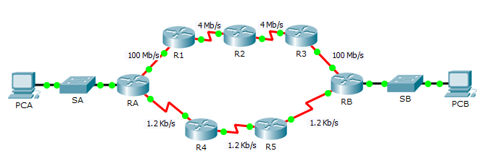

1. Open up the packet tracer file “Path Selection”
2. PCA wants to communicate with PCB and vice versa.
3. Path that the data takes between these devices can travel through R1, R2 and R3 or it can travel through R4 and R5.
4. Process that routers select the best path depends on the routing protocol.
5. RIP & EIGRP are both classified as distance vector protocols.

With all this in mind, what is your answer to Q1 and Q2

**Q1**

Based on the metric used by EIGRP, **predict** what will be the path that a packet will take in travelling from PCA → PCB?  
(list the routers that the packet will travel through)

The communication between PCA and PCB happen as follows. From PCA the data would pass through router RA, R1, R2, R3 and RB to reach PCB.

**Q2**

Based on the metric used by RIP, **predict** what will be the path that a packet will take in travelling from PCA → PCB?  
(list the routers that the packet will travel through)

The communication between PCA and PCB happens as follows. From PCA the data would pass through router RA, R4, R5 and RB to reach PCB.

1. We will prove the paths that we predicted above….

We will check the EIGRP path first.  
  
Check the routing table on RA and the following appears

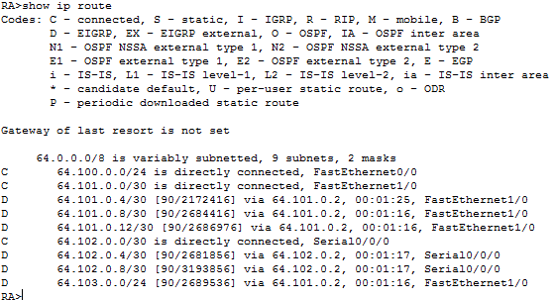



✓

1. On PCA run the Tracert command to PCB’s IP address.

Insert a screenshot of the command here

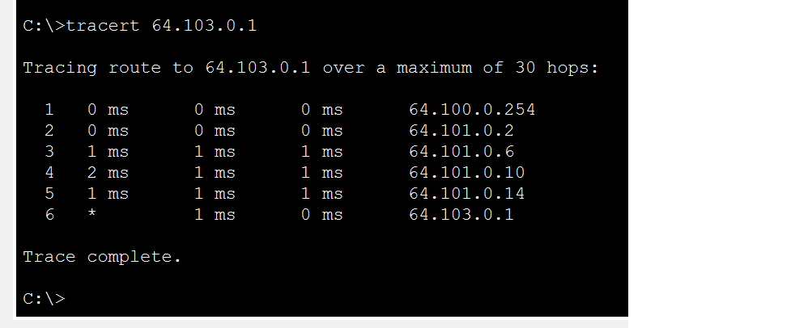

How man hops do the packets take to get to PCB?

5

What is the minimum bandwidth on the path taken by the packets?

4 Mbps

1. Both RIP and EIGRP protocols are configured on the routers and yet we only see EIGRP on the route table?

Why?

The routers ignore RIP route that it generates, because they prefer EIGRP. Cisco routers use a scale called administrative distance and we need to change that number for RIPv2 in **RA** to make the router prefer the protocol.

1. We will now change the AD of RIP on RA to 89.   
     
   We then re-run the show ip route command.

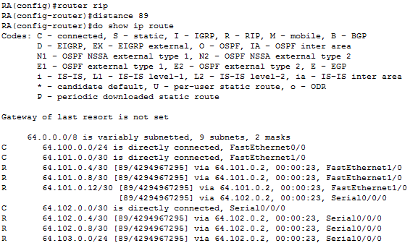

See how RIP has now replaced EIGRP as the routing protocol.

✓

1. Now go back to PCA and run the tracert command again to PCB.  
     
   The top trace is that via EIGRP while the bottom is that of RIP.

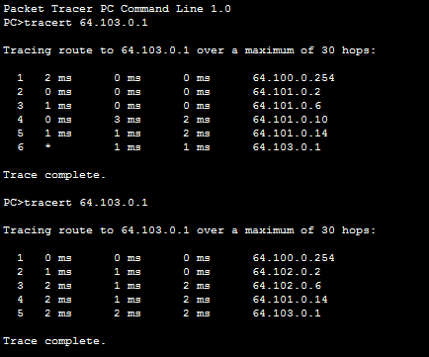

How man hops do the packets take to get to PCB?

4

What is the minimum bandwidth on the path taken by the packets?

1.2 Kbps

